**52167 Programming & Scripting**

**Exercise 1**

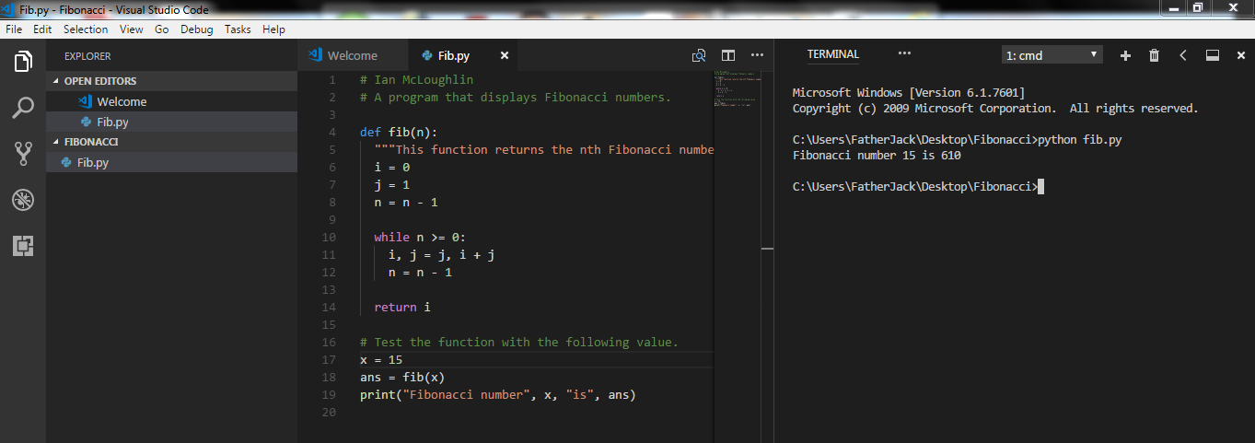

My name is Oilbhe, so the first and last letter of my name (O + E = 10 + 5) give the number 15. The 15th Fibonacci number is 610.

#### Exercise 2

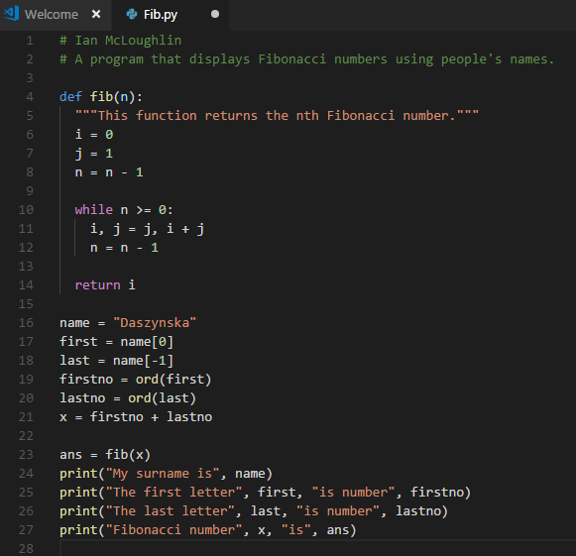

My surname is Daszynska, the first letter D is number 68, the last letter a is number 97, Fibonacci number is 165.

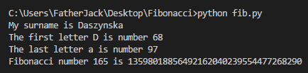

# Python ord()

The ord() method returns an integer representing Unicode code point for the given Unicode character. It returns the decimal equivalents of the ASCII characters. *D* = 68 & *a* = 97.

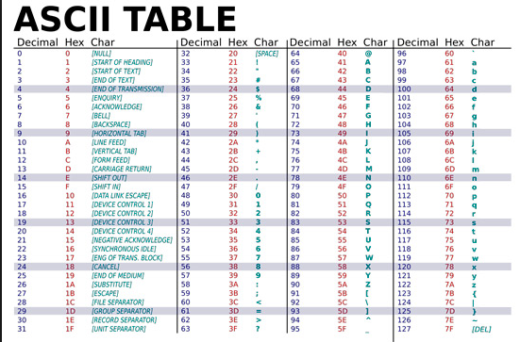

Oilbhe Daszynska